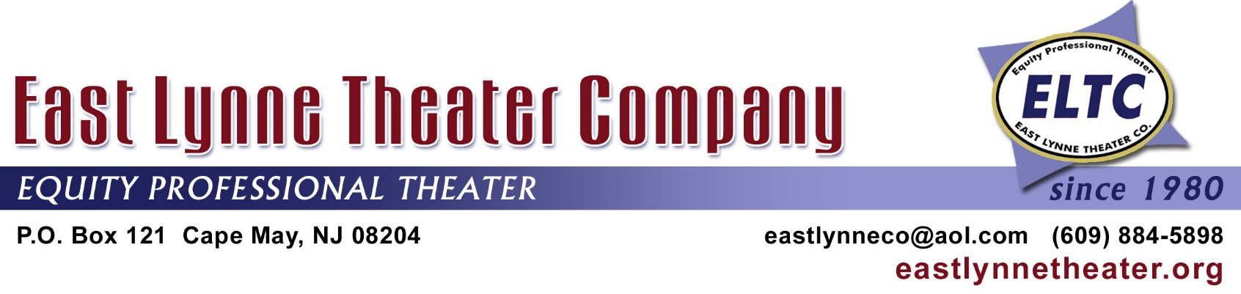

ADVERTISING IN 2019

Rates for Color ads: Full page = $775 Half-page = $475 Quarter-page= $325

Rates for B/W ads: Full Page = $675 Half-page = $425 Quarter-page = $275

*Cover: Outside Back = $1,050; Inside Back or Front = $950

(*Note: Recent advertisers for cover back page and inside cover will have first choice to renew.)

SIZES: Full page: 4 ¾ w X 7 ¾ h Half- page: 4 ¾ w X 3 ¾h Quarter-page:: 2 ½ w X 3 ¾ h

Send ad to ELTC via e-mail (pdf or jpeg) by May 12 to be in ELTC’s full season beginning
with Summerland on June 12. Any ads sent by March 1, we will try to create new full pages for our March events’ playbill. Pages from 2018 will be used in March, unless full pages can be replaced.

4 ¾ ” width for full-page and half-page ad

3 ¾ ” high
for half page and
quarter page ad

7 ¾ ” high for full-page ad

2 ½” wide for
quarter page ad

-----------------------------------------------------------------------------------------------------------------------------------------------
Please return at least this part of the form to the office of the not-for-profit ELTC.

BUSINESS_________________________ CONTACT PERSON__________________________________

DATE____________ POSITION_______________ AD SIZE(b/w or color)___________________________

ADDRESS_________________________ E-MAIL___________________ PHONE____________________

Please check one:

No need to send a separate bill: the check is enclosed:_____

Send an invoice to the above person and address: check will be mailed in a month:_____

Send an invoice to the following person and address: check will be mailed within a month:___

Name/Address:_________________________________________________________________________

