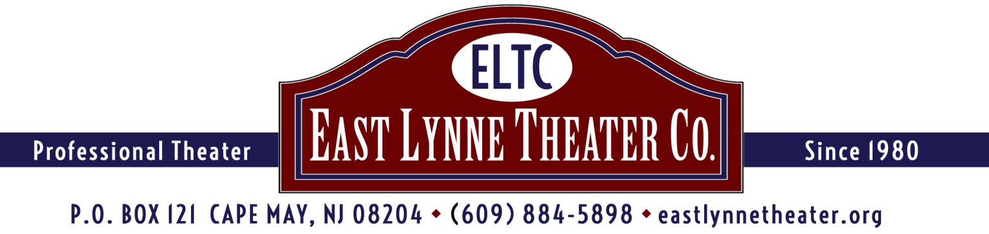

SPONSORSHIPS
ELTC'S GOLF FUNDRAISER TO SUPPORT
THE 2020 SEASON and ENDOWMENT FUND
CAPE MAY NATIONAL GOLF CLUB
Route 9 and Florence Avenue, Erma, NJ (Exit 4A, Garden State Parkway)
Monday June 1, 2020
Registration at Noon Reception at 5:00
Scramble Style! Shotgun Start!
For details, visit www.tinyurl.com/CM-golf-2019

SPONSORSHIPS
HOLE SPONSOR $100: Sign at one of the holes indicating the sponsor. This can be your name or a business name.
BRONZE SPONSOR $250: Have your name, with logo, listed as Bronze sponsor in all advertising and printed material, AND includes one player in the tournament.
SILVER SPONSOR $500: Have your name, with logo, listed as Silver sponsor in all advertising and printed material, AND includes 2 players in the tournament.
GOLD SPONSOR $750: Have your name, with logo, as a Gold sponsor in all advertising and printed material, AND, includes 3 players in the tournament.
EVENT SPONSOR $1,000: Have your name, with logo, as the Event sponsor in all advertising and printed material, AND includes a foursome in the tournament!
---------------------------------------------------------------------------------------------------------------------------------------
Please return at least this part of the form with your check made out to: East Lynne Theater Company and mail to P.O. Box 121, Cape May, NJ 08204. ELTC is a nonprofit 501(c)3.

BUSINESS_________________________ CONTACT PERSON____________________________

SPONSORSHIP LEVEL_____________________________________________________________

IF SPONSORING A HOLE, HOW WOULD YOU LIKE IT NAMED?____________________________

_________________________________________________________________________________

ADDRESS_________________________ E-MAIL___________________ PHONE_______________

THANK YOU!

