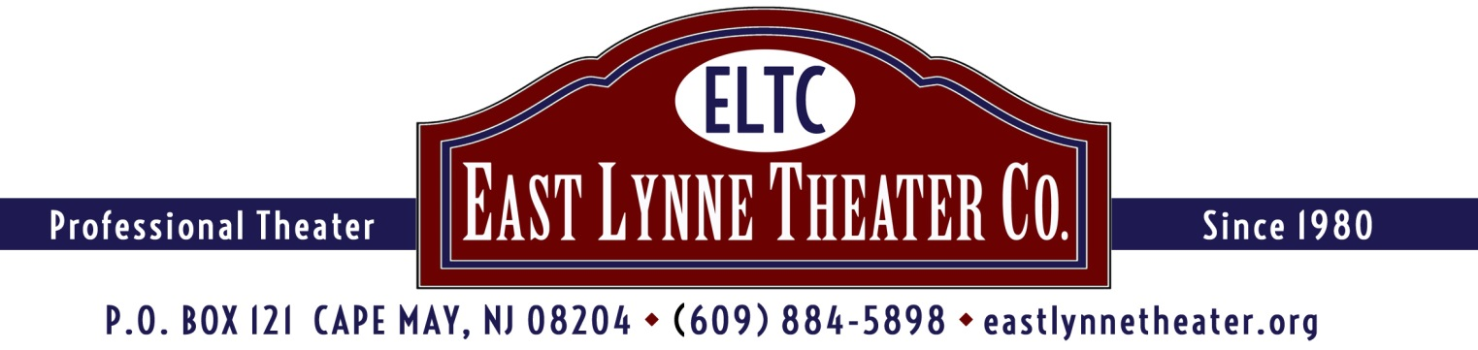

ELTC'S GOLF FUNDRAISER TO SUPPORT
THE 2020 SEASON and ENDOWMENT FUND
CAPE MAY NATIONAL GOLF CLUB
Route 9 and Florence Avenue, Erma, NJ (Exit 4A, Garden State Parkway)
Monday June 1, 2020 (Rain date, June 2nd)
Registration at Noon Reception at 5:00
SCRAMBLE SHOTGUN START!
Don't Have a Foursome?
We can match you with others to create a foursome.
Prizes include Gift Certificates,
Wine and Theater Tickets.
$10,000 Hole in One Prize
Additional Contests:
Closest to the Pin, Best Putt, Longest Drive, Best Dressed
After the tournament, enjoy a reception, with cash bar, catered by
The Chalfonte Hotel at the Club.

$100 to play and attend the reception; $50 for a guest to attend the reception only.
Proper Golf Attire
QUESTIONS? CONTACT ELTC at 908-625-2557

---------------------------------------------------------------------------------------------------------------------------------------

Please return this part of the form with your check made out to: East Lynne Theater Company
Mail to: ELTC, P.O. Box 121, Cape May, NJ 08204. ELTC is a nonprofit 501(c)3.

PLAYER(S) NAMES: _______________________________________________________________

ATTENDING RECEPTION BUT NOT PLAYING:__________________________________________

ADDRESS________________________________________________________________________

E-MAIL_______________________________ PHONE___________________________

THANK YOU!

