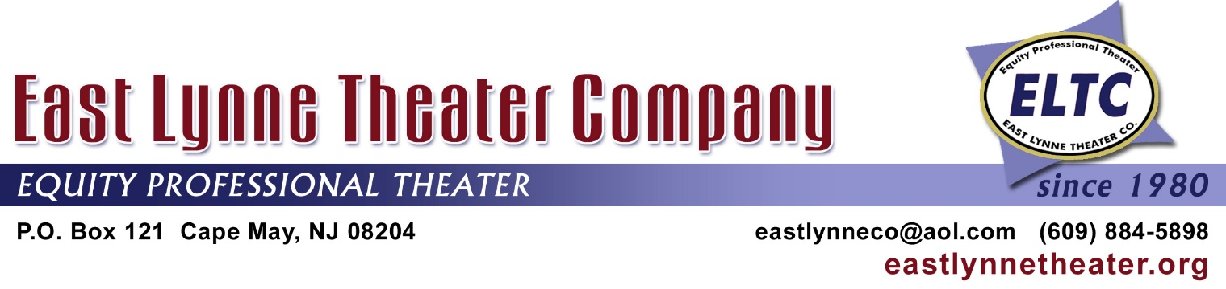

TALES OF THE VICTORIANS FOR 2019
Our 30th Year of Presenting This Unique Program

For a $100 donation to the nonprofit East Lynne Theater Company,
a storyteller will come to you!
It’s a wonderful way to introduce yourself to those who may not know much about you.

The Host and/or Hostess Agrees to:

* Provide a location, which is usually on an outdoor front porch, but the location could be inside, i.e.,
a tea shop or parlor. The important thing - that there is enough room for at least ten chairs and a
place for the reader(s) to stand. (Audiences range from usually 4-15, but sometimes up to 20.)
* Provide refreshments (cookies, cheese and cracks, etc.) and drinks (ice tea, lemonade, etc.).
* Allow a small sign announcing the TALES to be placed so that those walking by may see it a few
days before and on the day of the TALES.
* Help with promotion, if possible, through social media including Facebook, Twitter, and e-blasts, and
your own web site.
* Pay $100 either before the reading or on the day of to ELTC.
* Allow ELTC to collect $12 from each person attending, except those ages 12 and under are free,
and if the venue is an accommodation such as a B&B or hotel, then there is also no charge for your
guests.
East Lynne Theater Company Agrees to:
* Provide and pay for a storyteller to read classic tales from America’s diverse repertoire.
* Place targeted magazine and newspaper ads listing your venue, i.e., MAC’s “This Week in Cape
May” and “Exit Zero.”
* List the venue as a location for TALES in our Newsletters, Playbills, and Web Site.
* Include the venue’s name in press releases related to TALES, as well as targeted social media e-
blasts, Facebook, and Twitter.
* Give the venue the funds received by guests attending TALES, as long as $100 total minimum is still
retained by ELTC.
* Guests staying at the inn or B&B who attend TALES, and not asked to pay the $12.
* Link the venue’s web site to ours.
---------------------------------------------------------------------------------------------------------------------------------------
Please return at least this part of the form to the office of the not-for-profit ELTC.

BUSINESS_________________________ CONTACT PERSON____________________________

DATE_______ POSITION_______________ PREFERRED DATE(S) FOR TALES_______________

ADDRESS_________________________ E-MAIL___________________ PHONE_______________

Please check one:

No need to send a separate bill: the check is enclosed:_____

The $100 will be paid on the day of the TALES, either in full, or added to the amount taken at the gate so that the full $100 is paid to ELTC:_____

Send an invoice to the above person and address: check will be mailed in a month:_____
Name/Address:____________________________________________________________________

